In Search of Alpha Project

By: Marvin Halili and Fahad Datoo

Requirements:

1. Your task is to tell a story through data visualizations.
2. Focus on providing users an interactive means to explore data themselves.
3. Prepare a 10-minute presentation that lays out your theme, coding approach, data munging techniques, and final visualization.

Introduction

Our journey for this project started with the need to solve a daily challenge we face. How to process and visualize large amount of stock data- including both stock prices and fundamental data.

We continued to build from our previous project – analyzing the relationship between revenue growth for a company and its respective stock price. We wanted to include a larger data set for this project with about 39,000 rows of data including all companies in the S&P 500 index (one of the most broad-based and quoted indexes in the world). We also included both stock price data and fundamental data.

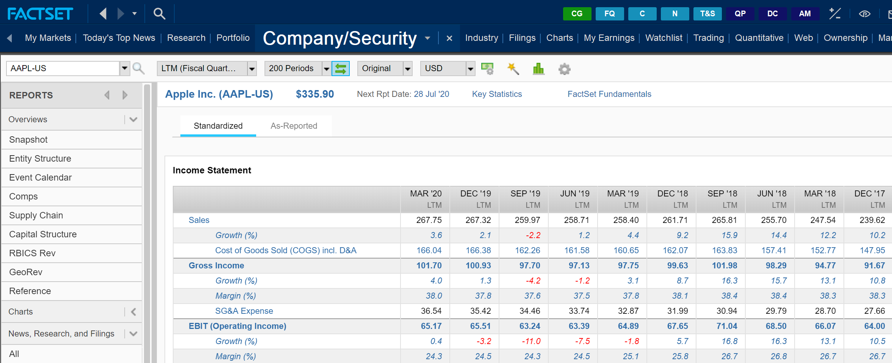

The Challenge & Solution

Our daily tasks include analyzing pricing data and fundamental data for thousands of companies around the world. Our current process includes using numerous complex spreadsheets, data sources such as Bloomberg, FactSet, Capital IQ and so on (see image above). With regards to this project we continued building our skill set using Python, making a connection with Postgre and then using Flask and JavaScript for our front end. The interactive nature of JavaScript has been quite beneficial to solving our initial challenge of showcasing large amounts of data in an interactive and presentable fashion.

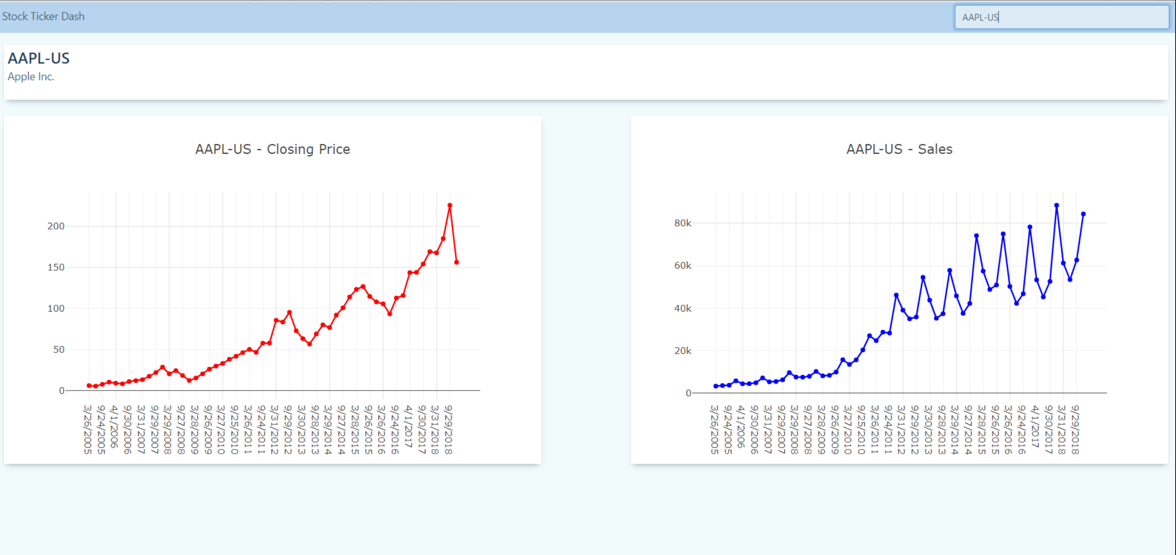

Our job includes not only finding the right companies to invest in, but present data to multiple stakeholders to clearly present the thesis for each company. One of the most challenging tasks is to present complex ideas in a clear and understandable fashion for all our stakeholders.

The above graph continues to show the moderate relationship between the stock price and revenue (sales) growth.

Additional Application of the Dashboard

The ease of use and interactive nature of Javascript, allow all members of our team to use this dashboard. We have team members that all have differing levels of technology expertise. This is why, a simple but elegant solution will go a long way to assist our team in increasing productivity and efficiency.

We are also quite excited that we can use this dashboard to present to both existing and prospective clients.

Conclusion

We are looking forward to continuing our journey and expanding our knowledge base on data analytics. We are quite excited to utilizing visualization tools and building on our existing tools and skill set. Special thanks to Dan for helping us on the front end and simplifying our lives! Thank you!

Appendix

